TINDAHAN NI ISKO | BU Labels 2025 Merchandise

Product Name | Variant | Product Image | Category | Price | Available Sizes | Google Drive Link
Pins
Tatak BUEÑO Series | Green |  | Pins | PHP 30.00 | One Size | Pins
Tatak BUEÑO Series | Red | 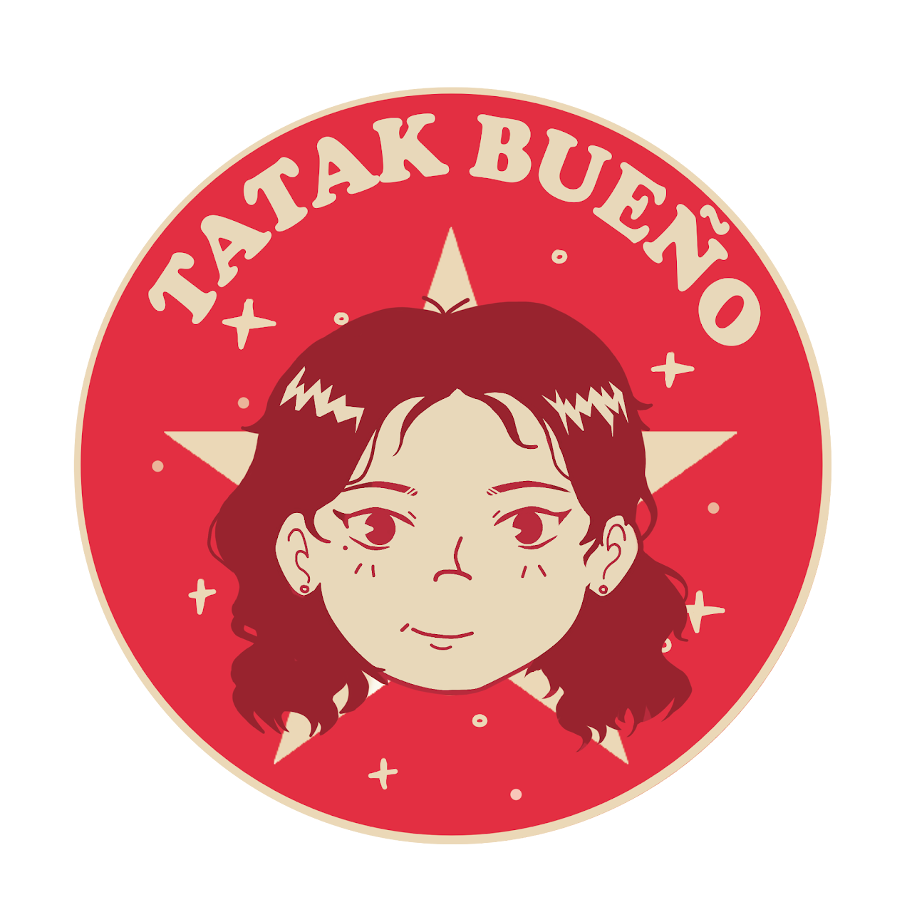 | Pins | PHP 30.00 | One Size | Pins
Tatak BUEÑO Series | Yellow |  | Pins | PHP 30.00 | One Size | Pins
Monochrome Series | TORCH |  | Pins | PHP 30.00 | One Size | Pins
Monochrome Series | BEUNIQUE |  | Pins | PHP 30.00 | One Size | Pins
Monochrome Series | Tatak BUEÑO |  | Pins | PHP 30.00 | One Size | Pins
Uni-Life Series | BUNIQUE |  | Pins | PHP 30.00 | One Size | Pins
Uni-Life Series | TORCH |  | Pins | PHP 30.00 | One Size | Pins
Uni-Life Series | COFFEE |  | Pins | PHP 30.00 | One Size | Pins
Stickers
Y2K Series | Iskolar ng Bayan |  | Stickers | PHP 10.00 | One Size | Stickers
Y2K Series | Tatak BUEÑO |  | Stickers | PHP 10.00 | One Size | Stickers
Y2K Series | BU is a Public School |  | Stickers | PHP 10.00 | One Size | Stickers
Y2K Series | Bicol University |  | Stickers | PHP 10.00 | One Size | Stickers
Y2K Series | GWA |  | Stickers | PHP 10.00 | One Size | Stickers
Sketchy Series | Bicol University (Yellow) | 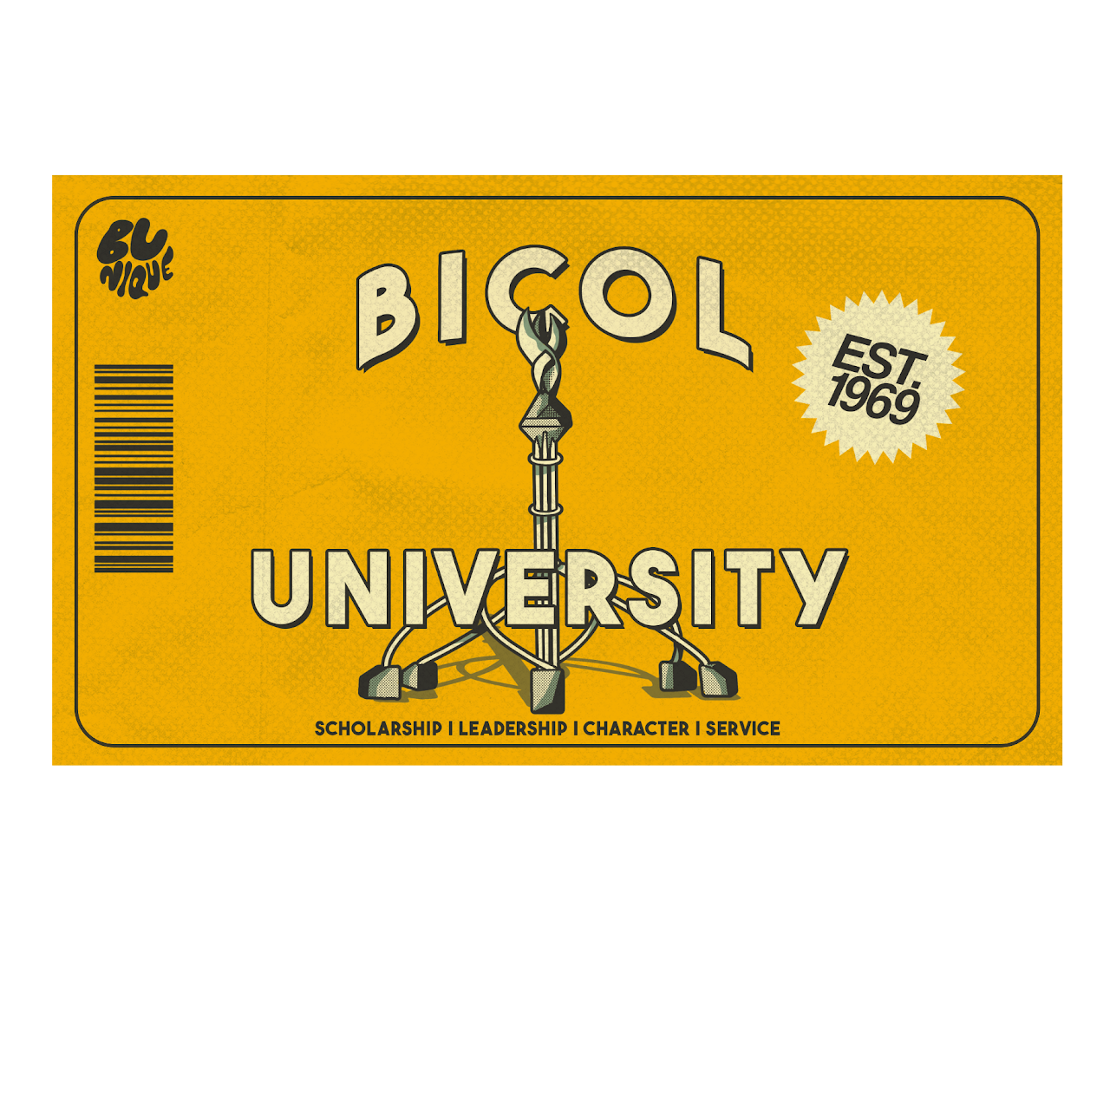 | Stickers | PHP 10.00 | One Size | Stickers
Sketchy Series | Bicol University (Orange) | 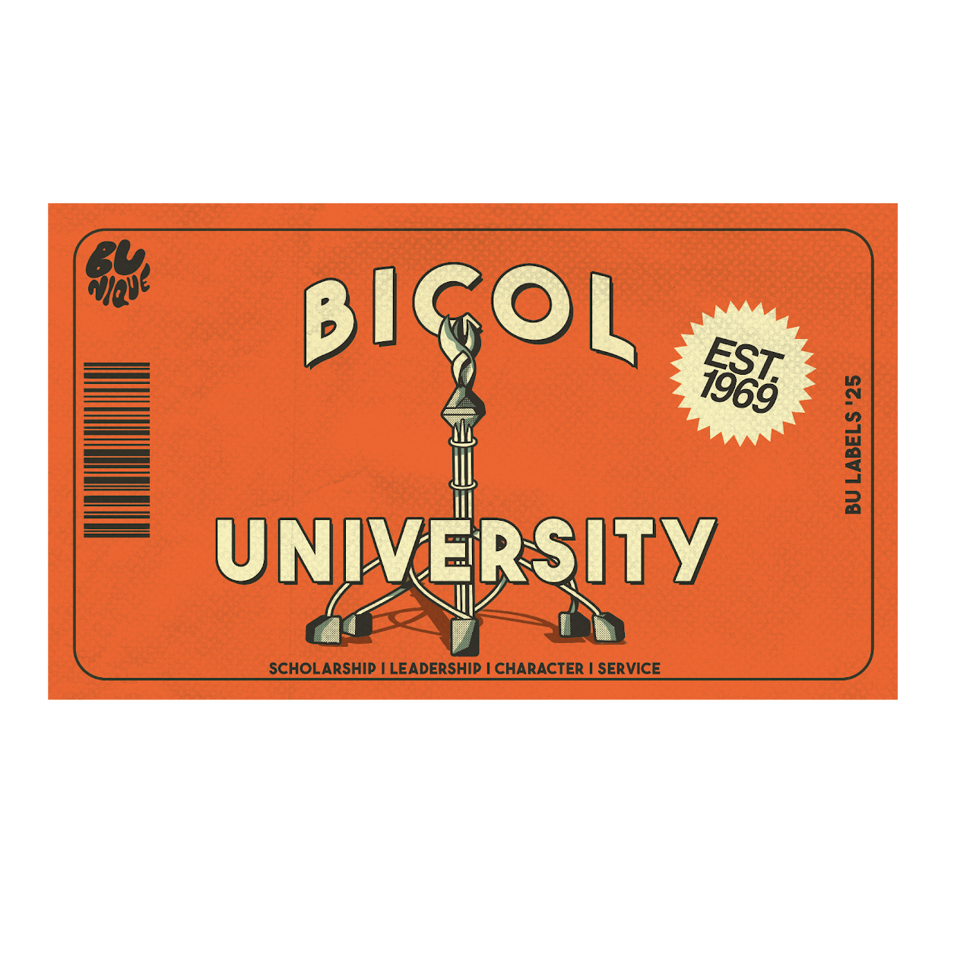 | Stickers | PHP 10.00 | One Size | Stickers
Sketchy Series | Fine State University |  | Stickers | PHP 10.00 | One Size | Stickers
Sketchy Series | BEUNIQUE |  | Stickers | PHP 10.00 | One Size | Stickers
Sketchy Series | Coffee |  | Stickers | PHP 10.00 | One Size | Stickers
Two-Color Series | Certified BUEÑO | 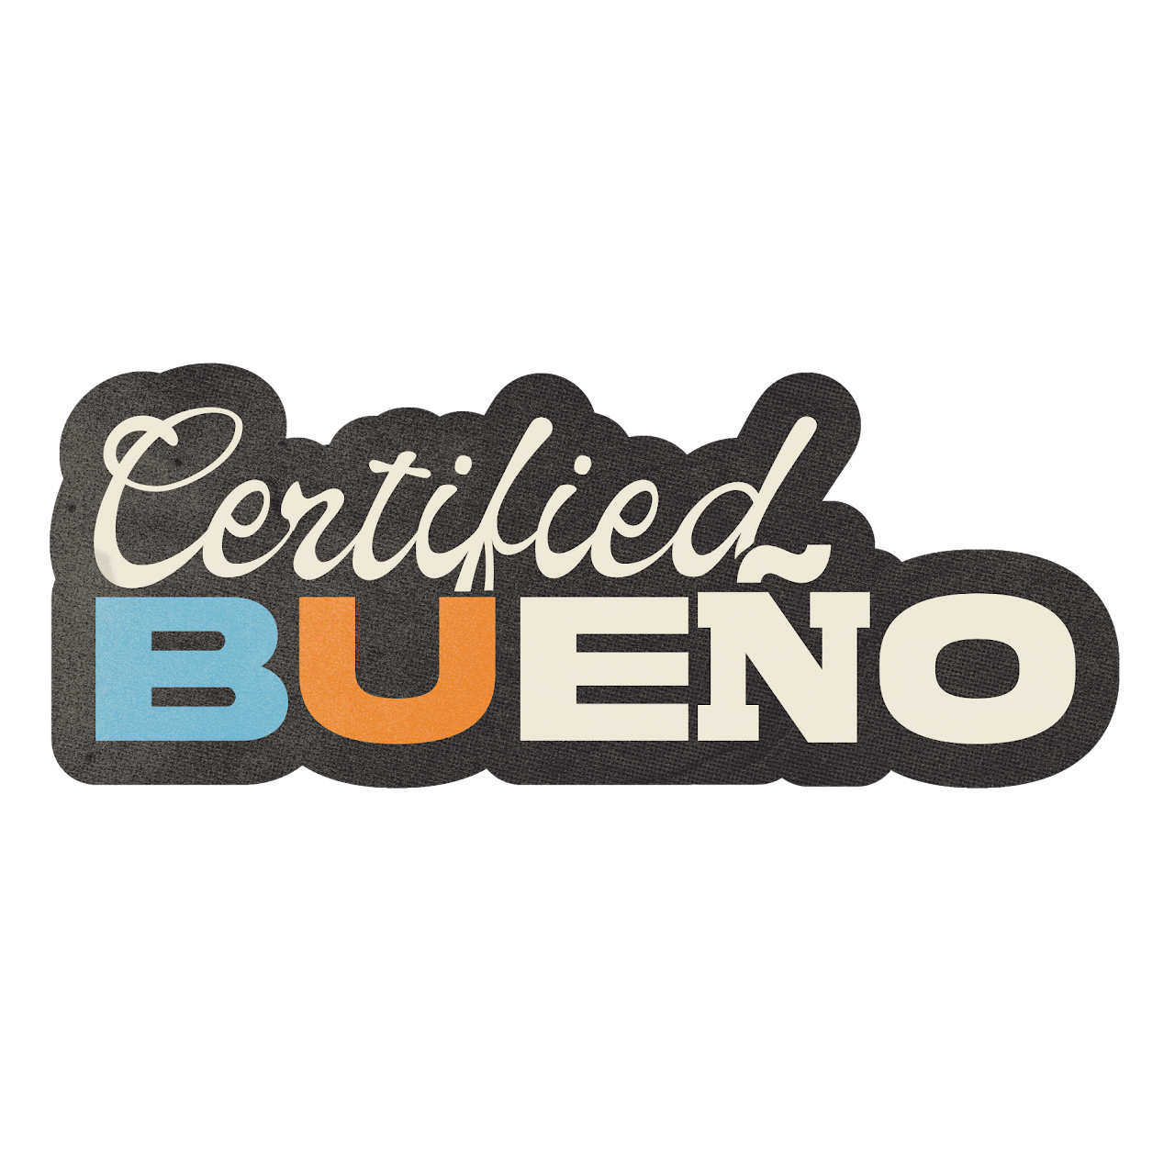 | Stickers | PHP 10.00 | One Size | Stickers
Two-Color Series | Glaringly |  | Stickers | PHP 10.00 | One Size | Stickers
Two-Color Series | Uno Cutie |  | Stickers | PHP 10.00 | One Size | Stickers
Two-Color Series | Padayon |  | Stickers | PHP 10.00 | One Size | Stickers
Two-Color Series | BEUNIQUE | 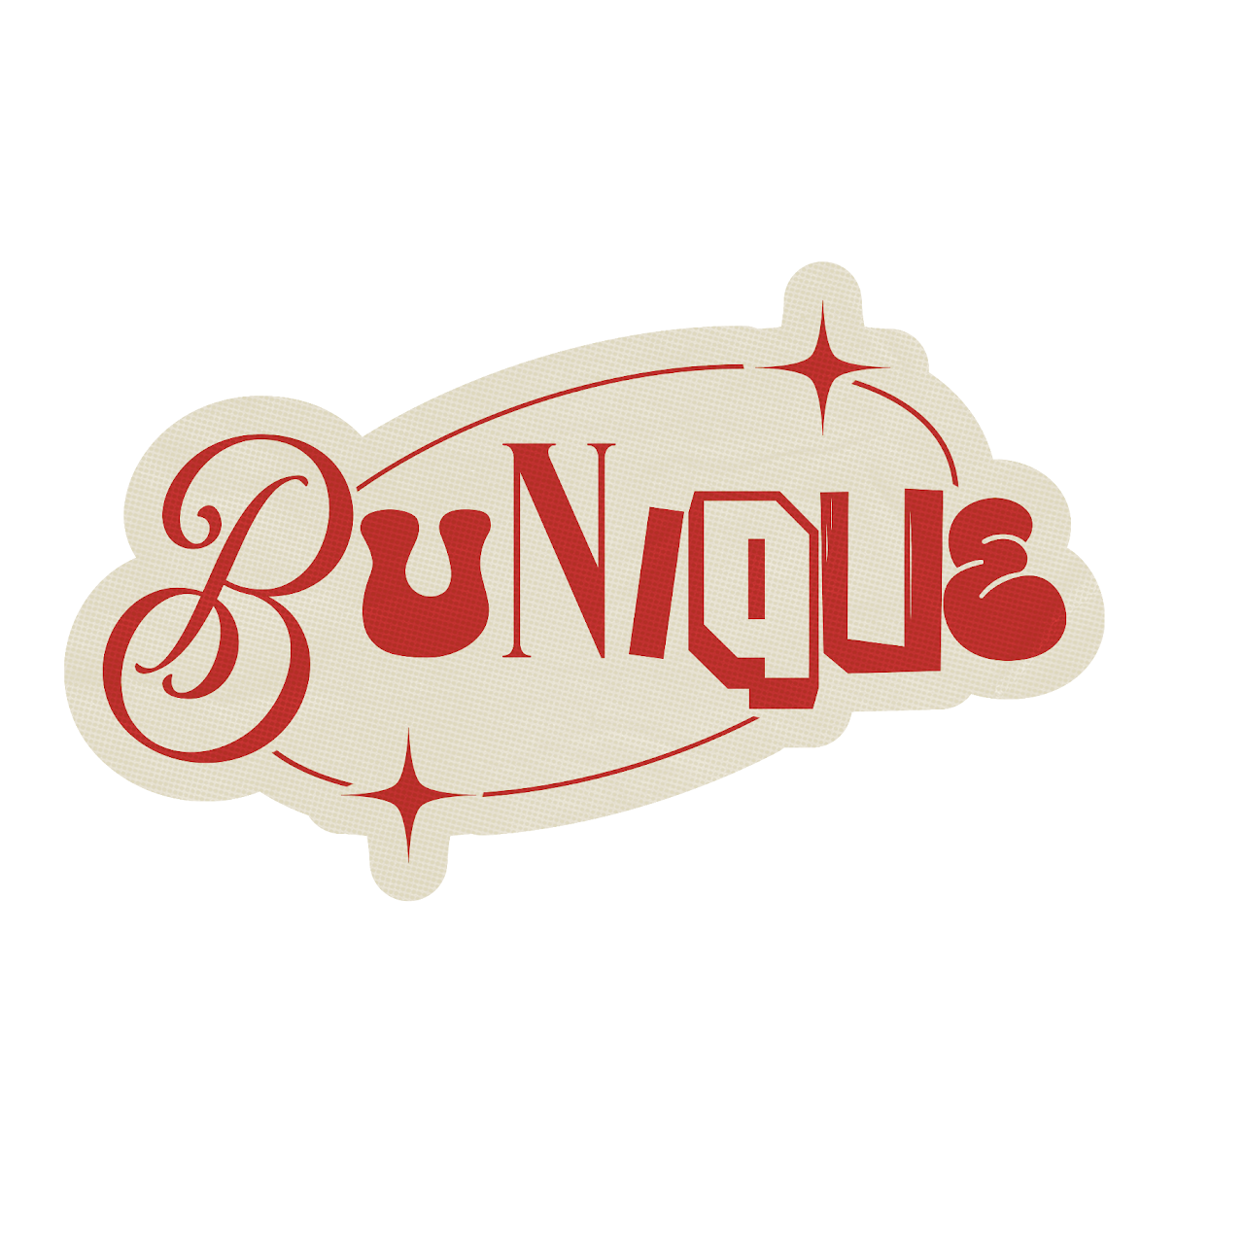 | Stickers | PHP 10.00 | One Size | Stickers
Caps
BUnique BU Labels | Green | 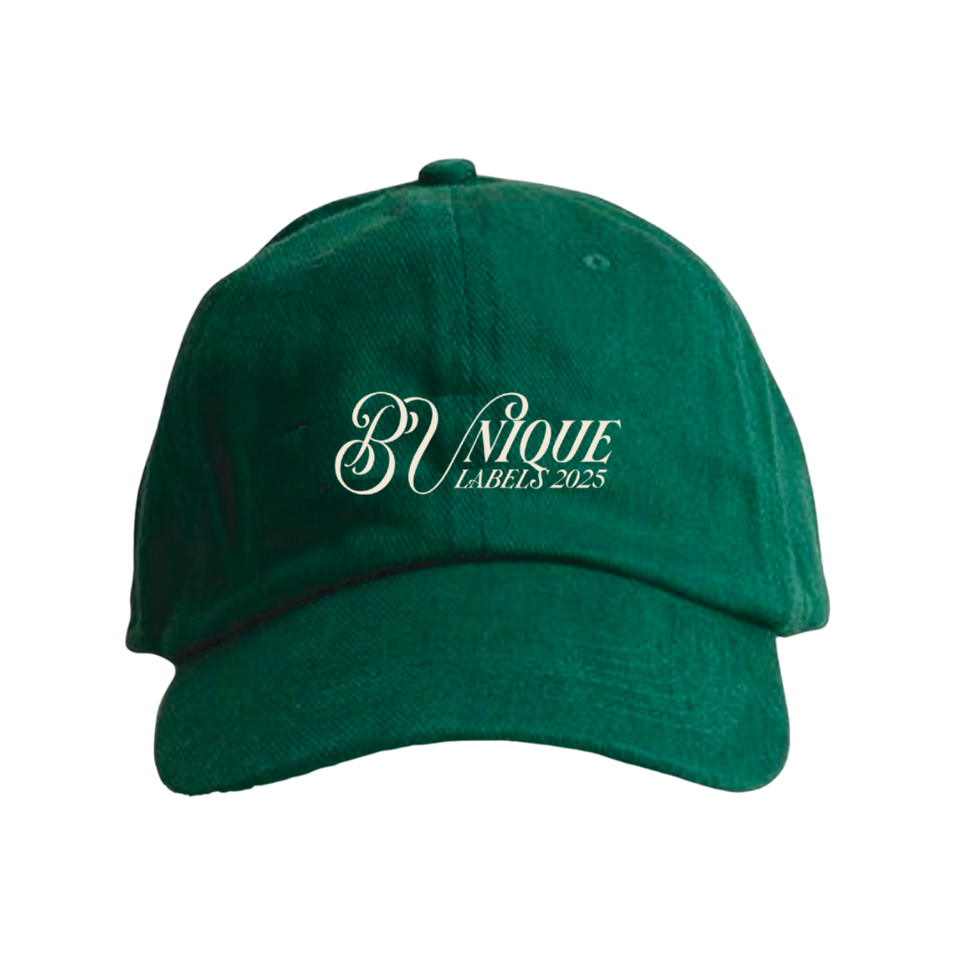 | Caps | PHP 300.00 | One Size | Caps
BUnique BU Labels | Black | 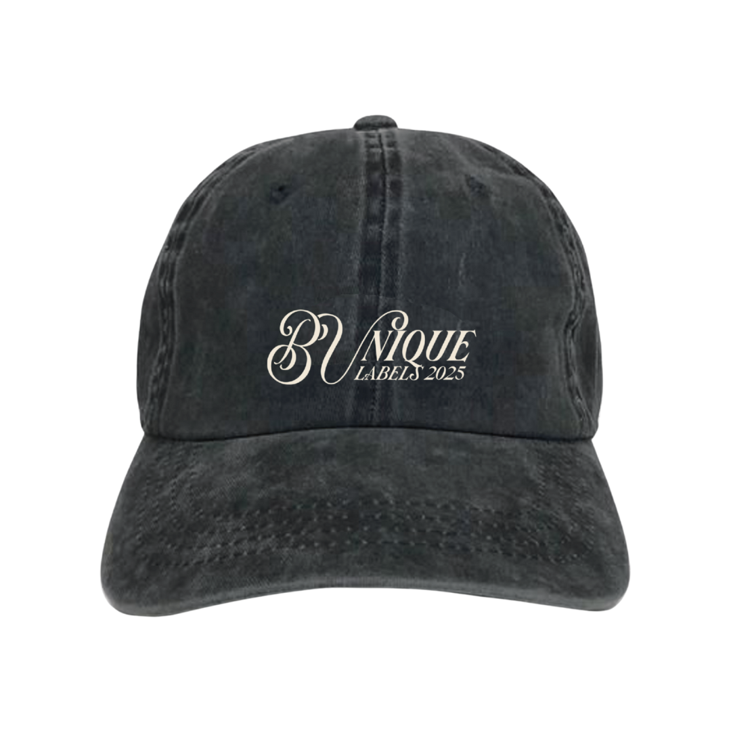 | Caps | PHP 300.00 | One Size | Caps
BUnique BU Labels | White | 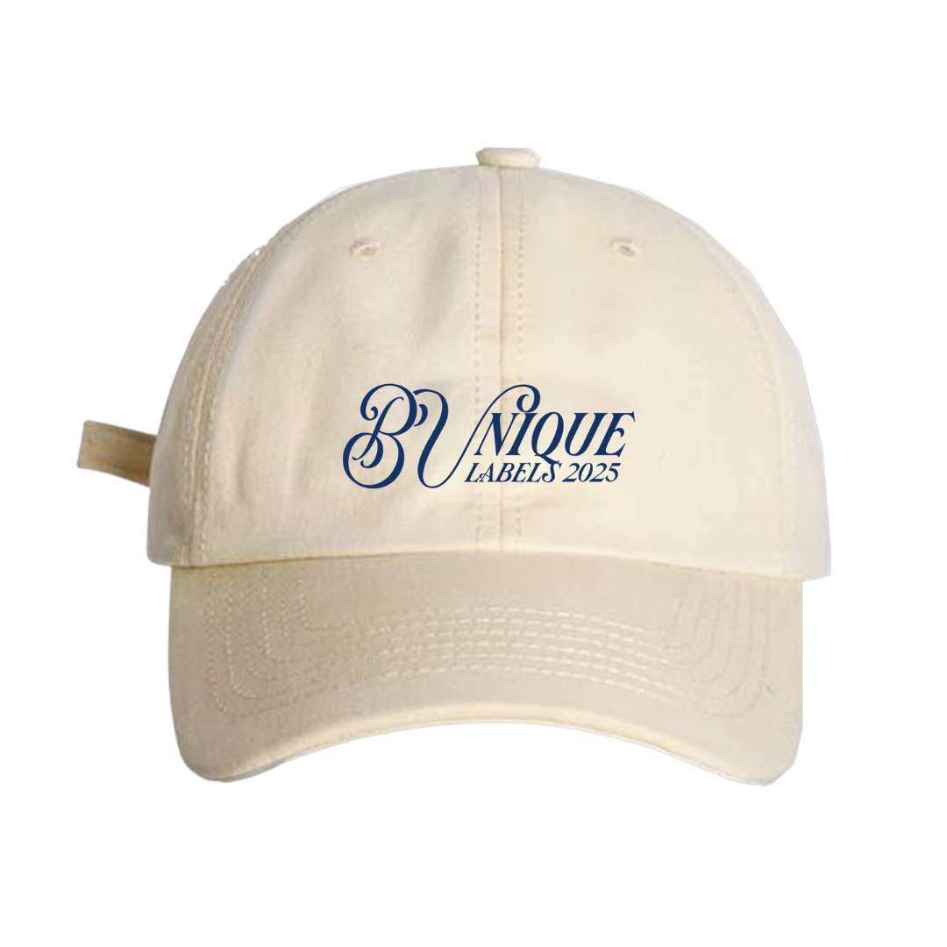 | Caps | PHP 300.00 | One Size | Caps
Bicol University | White | 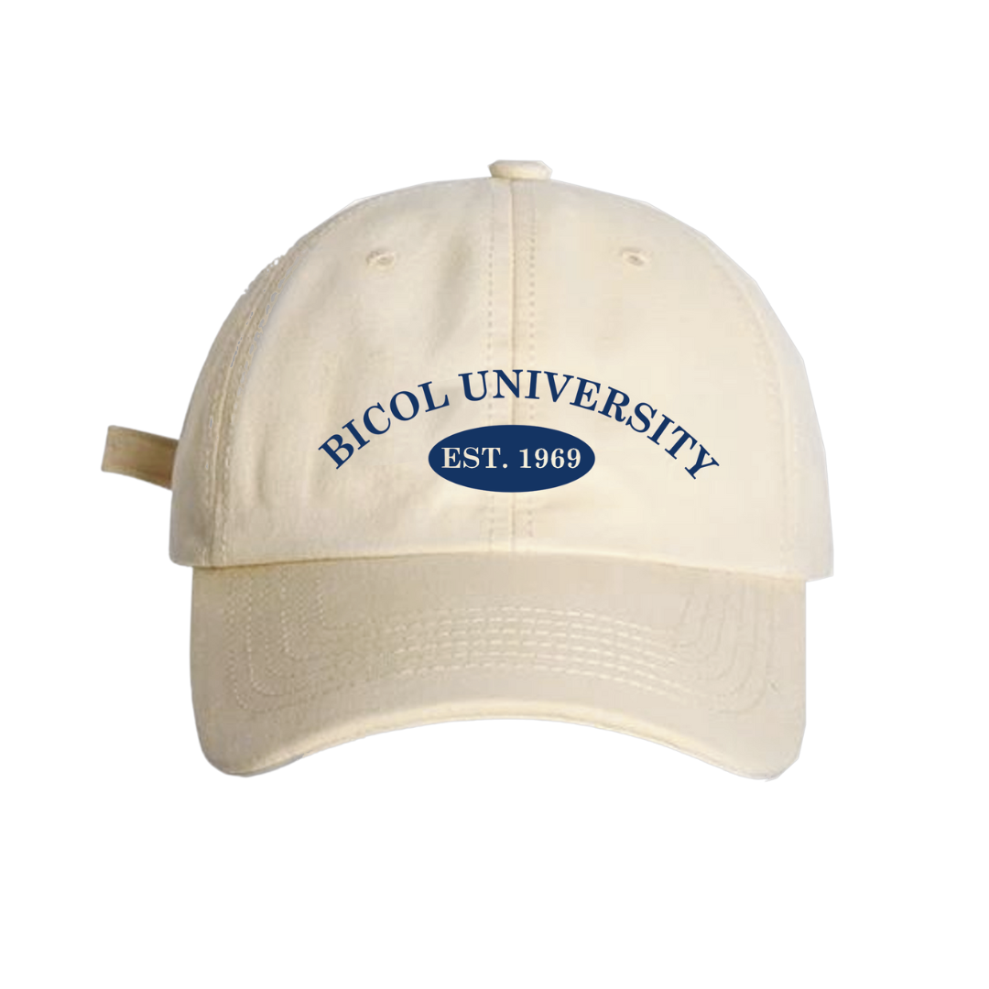 | Caps | PHP 300.00 | One Size | Caps
Bicol University | Green | 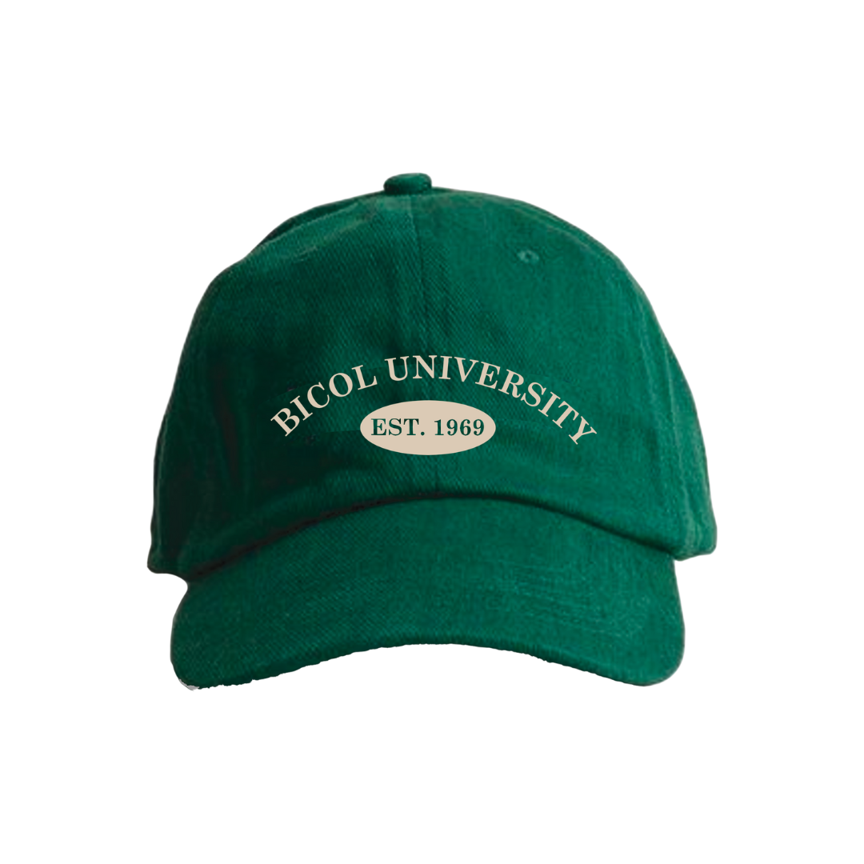 | Caps | PHP 300.00 | One Size | Caps
Bicol University | Black | 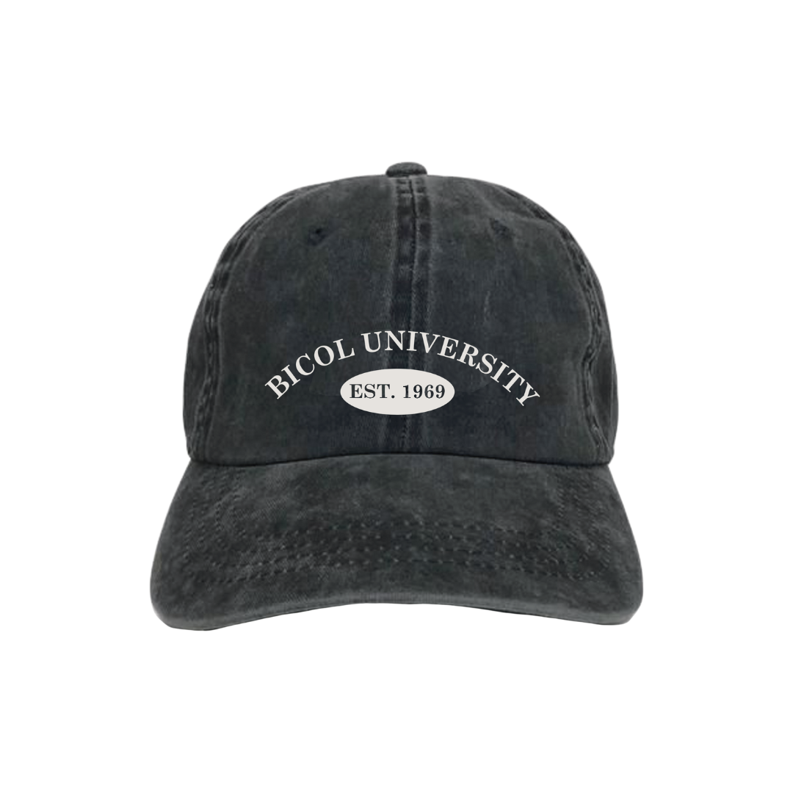 | Caps | PHP 300.00 | One Size | Caps
Tatak BUEÑO | Black | 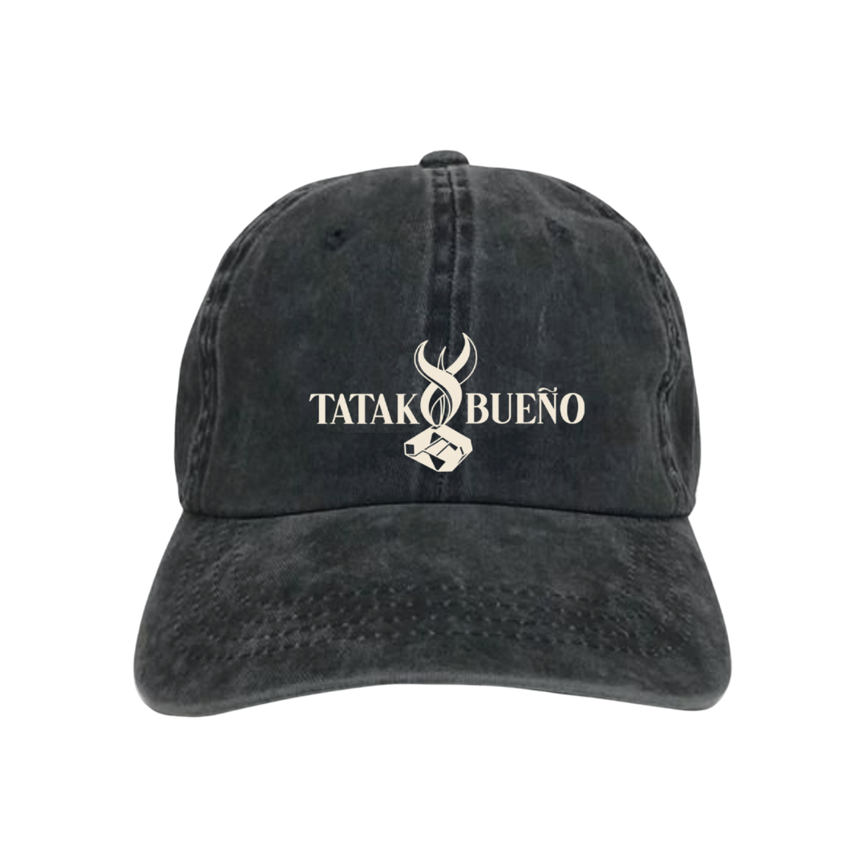 | Caps | PHP 300.00 | One Size | Caps
Tatak BUEÑO | White |  | Caps | PHP 300.00 | One Size | Caps
Tatak BUEÑO | Green | 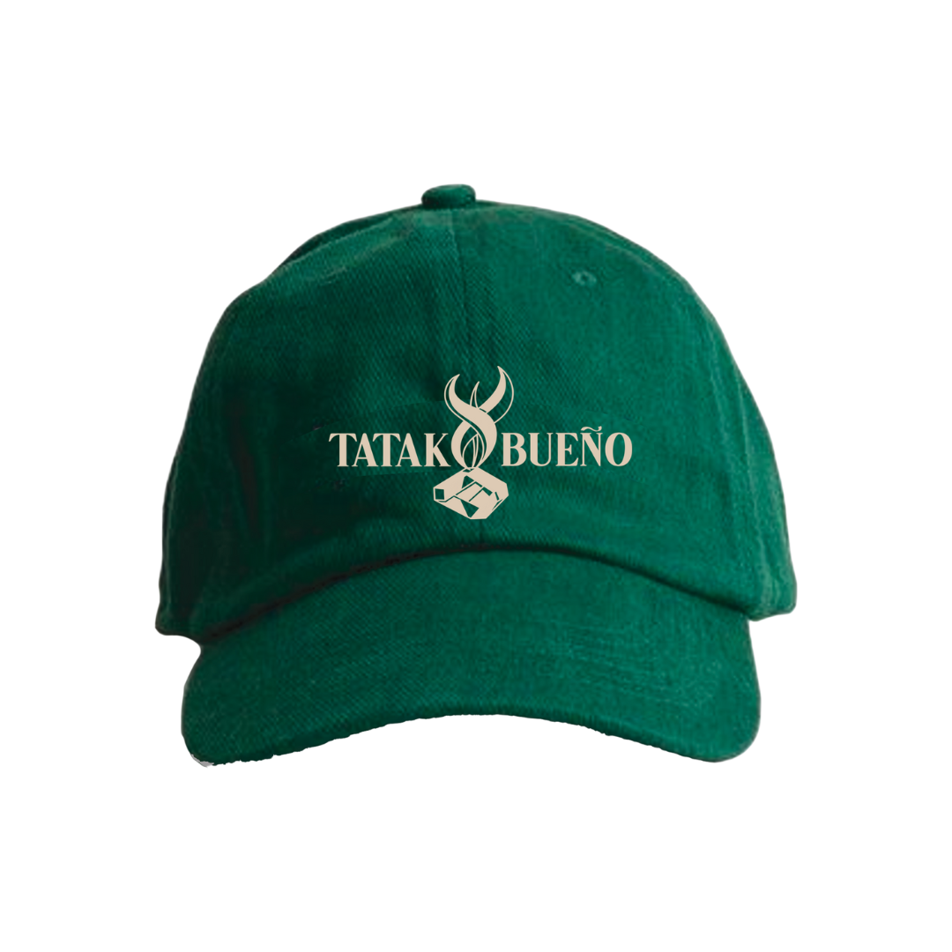 | Caps | PHP 300.00 | One Size | Caps
Hoodies
BU Labels 2025 Hoodie | Dark Cygnus (Dark Blue) | 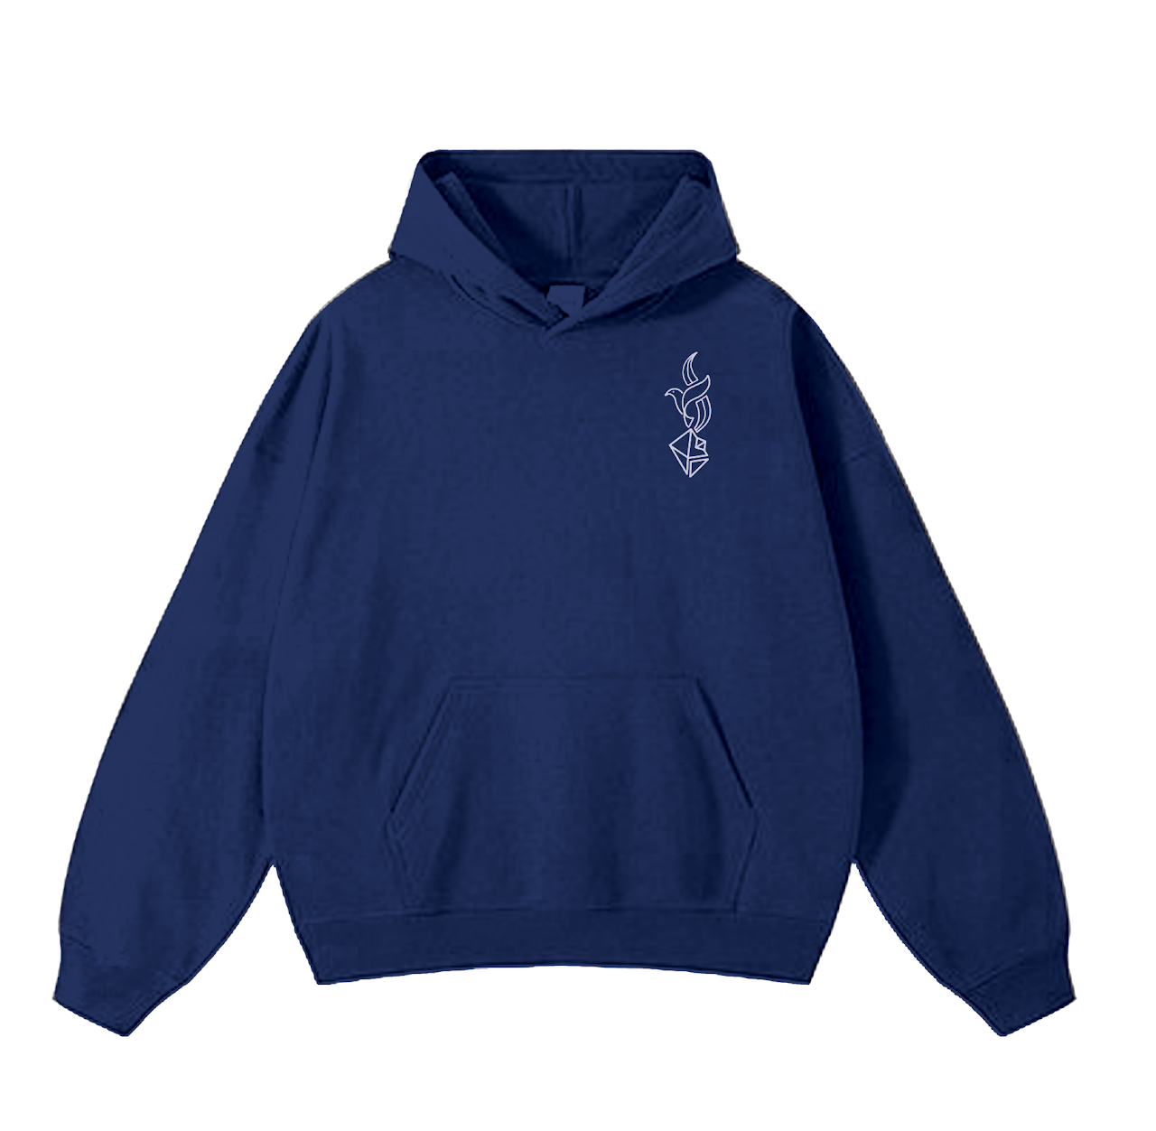 | Hoodies | PHP 750.00 | Small, Medium, Large, Extra Large | Hoodies
BU Labels 2025 Hoodie | Ophiuchus (Royal Blue) | 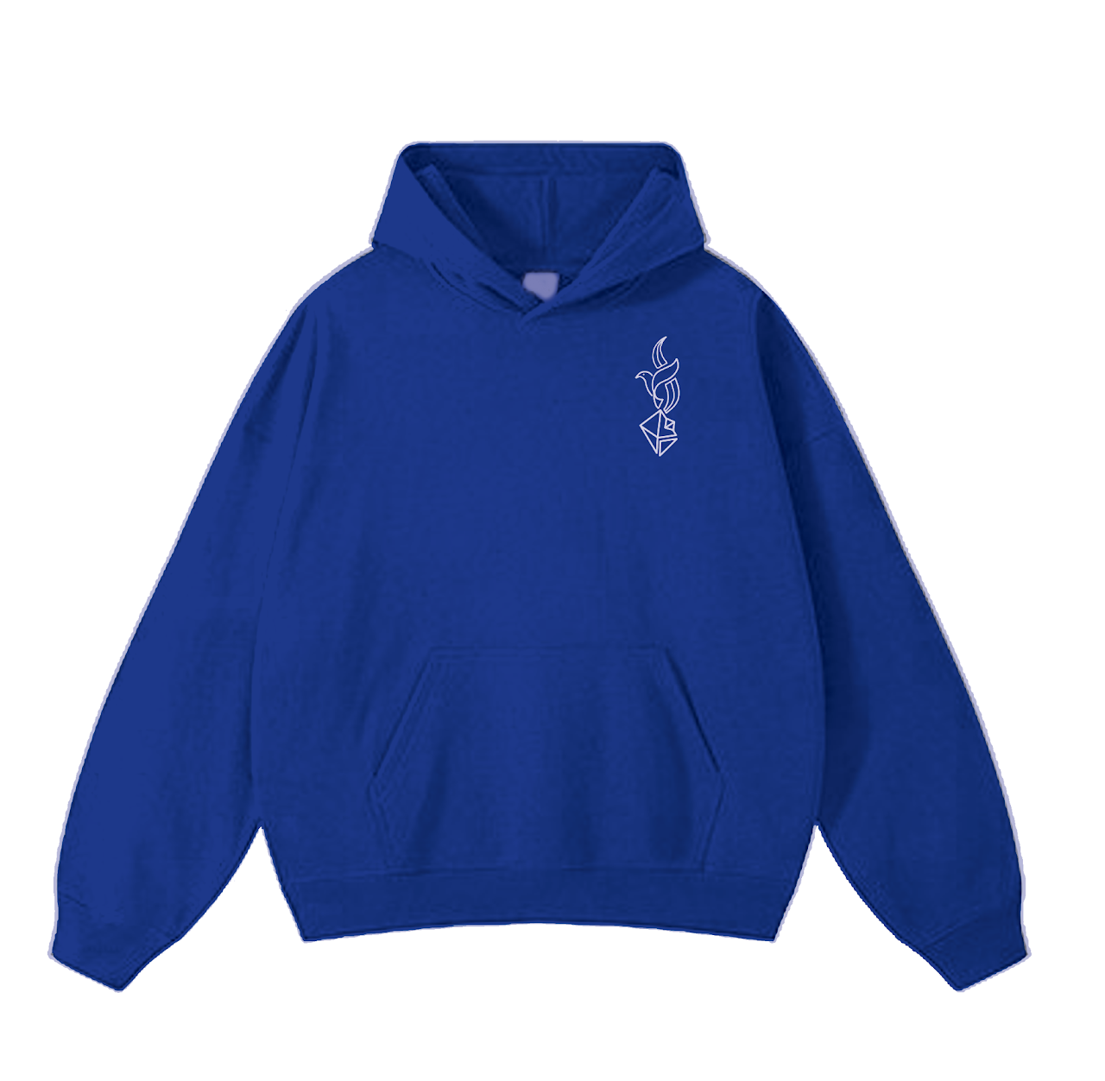 | Hoodies | PHP 750.00 | Small, Medium, Large, Extra Large | Hoodies
Bicol University Hoodie | Chameleon (Cream) | 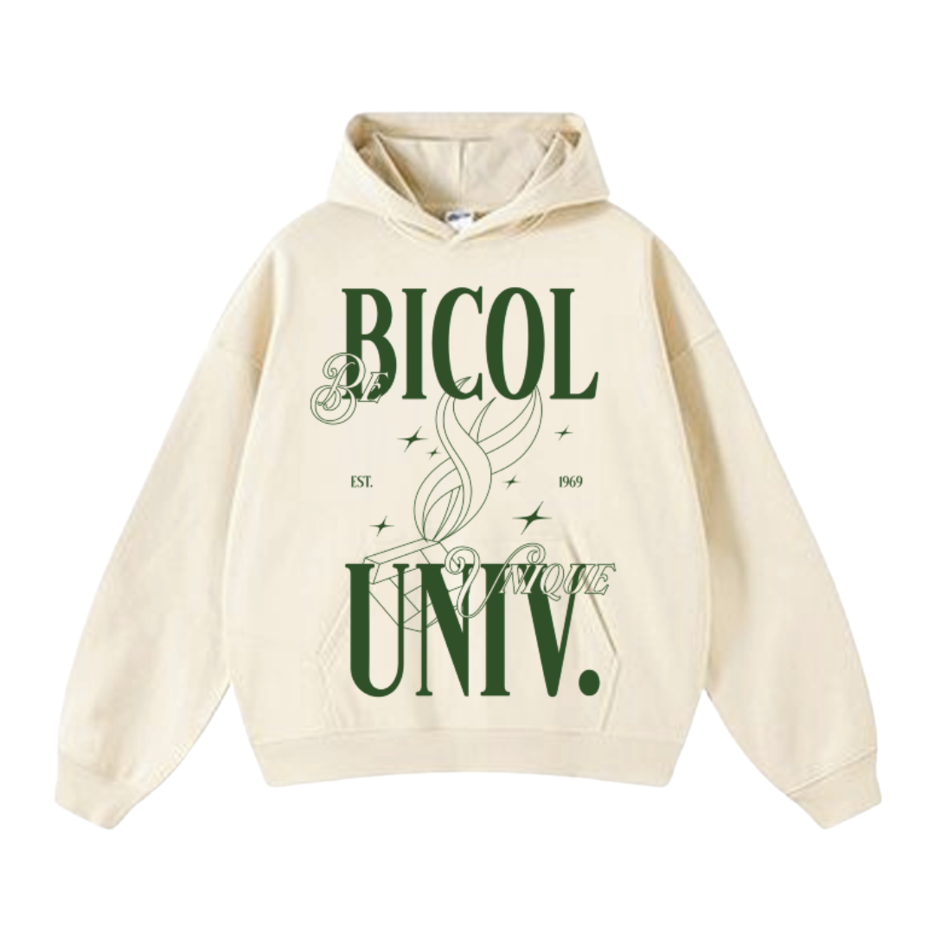 | Hoodies | PHP 750.00 | Small, Medium, Large, Extra Large | Hoodies
Bicol University Hoodie | Orion (Black) | 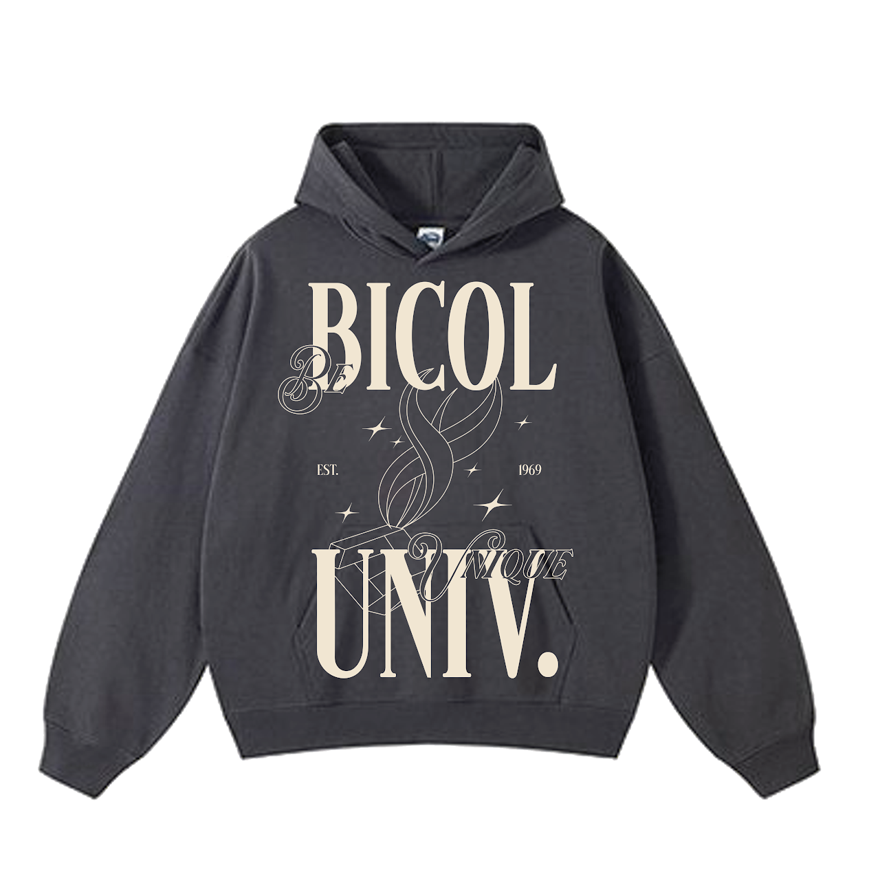 | Hoodies | PHP 750.00 | Small, Medium, Large, Extra Large | Hoodies
Shirts
Minimalist Torch | Cream | 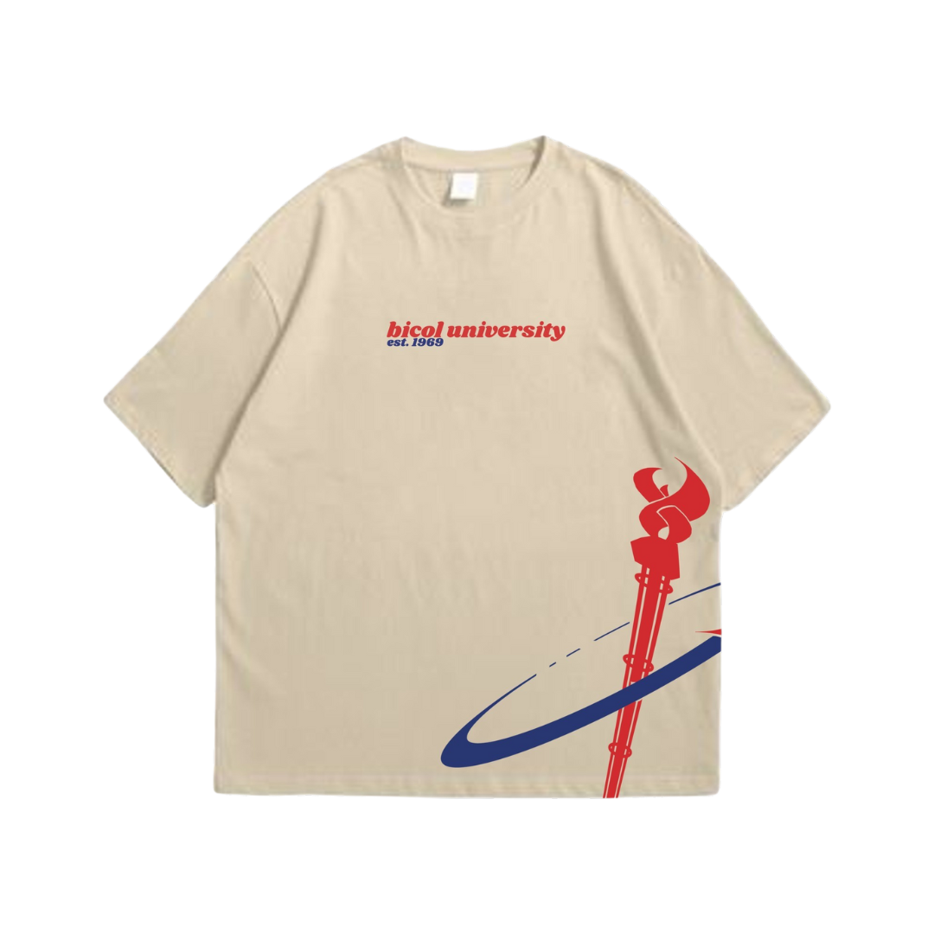 | Shirts | PHP 280.00 | Extra Small, Small, Medium, Large, Extra Large, 2XL | Shirts
Minimalist Torch | White | 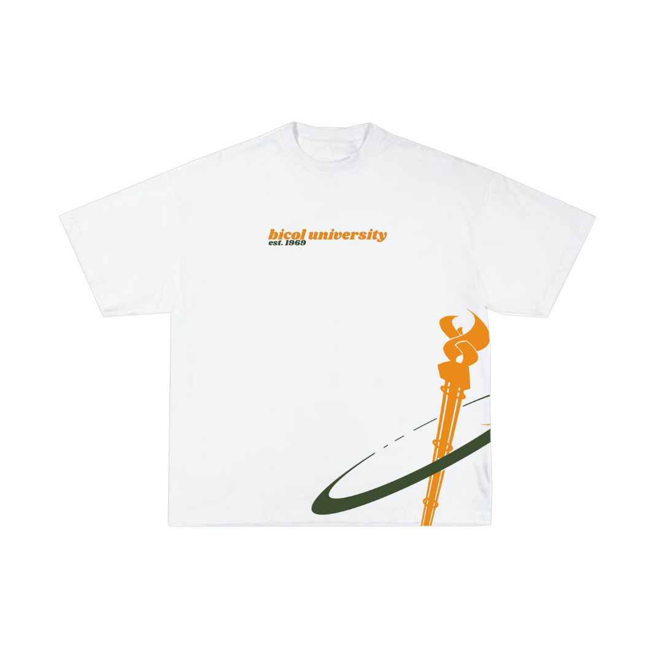 | Shirts | PHP 280.00 | Extra Small, Small, Medium, Large, Extra Large, 2XL | Shirts
Minimalist Torch | Black | 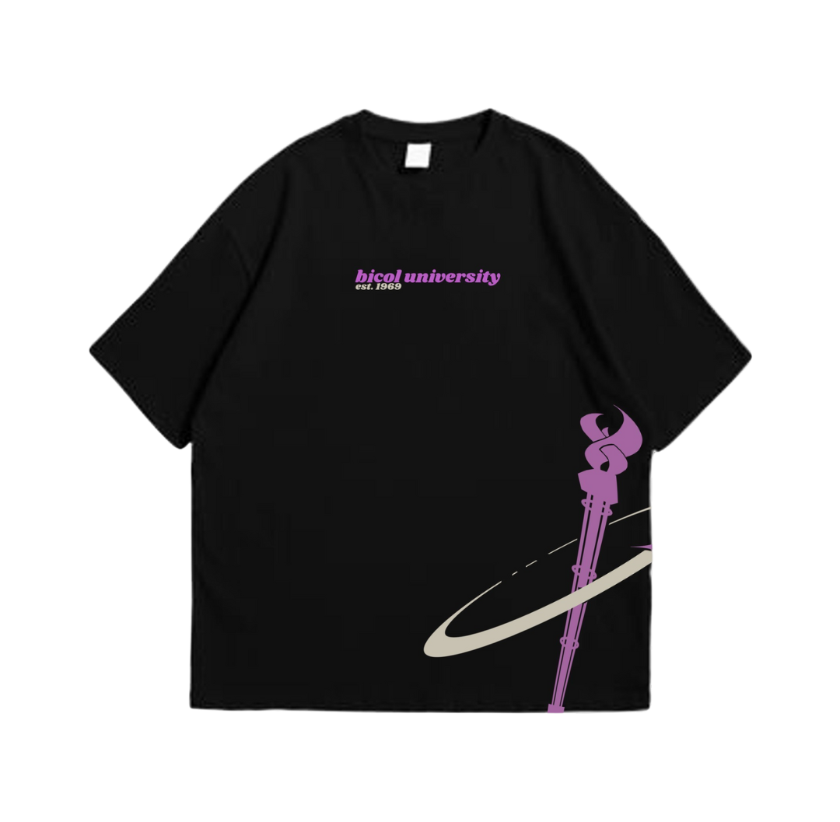 | Shirts | PHP 280.00 | Extra Small, Small, Medium, Large, Extra Large, 2XL | Shirts
Lauaan Street | White | 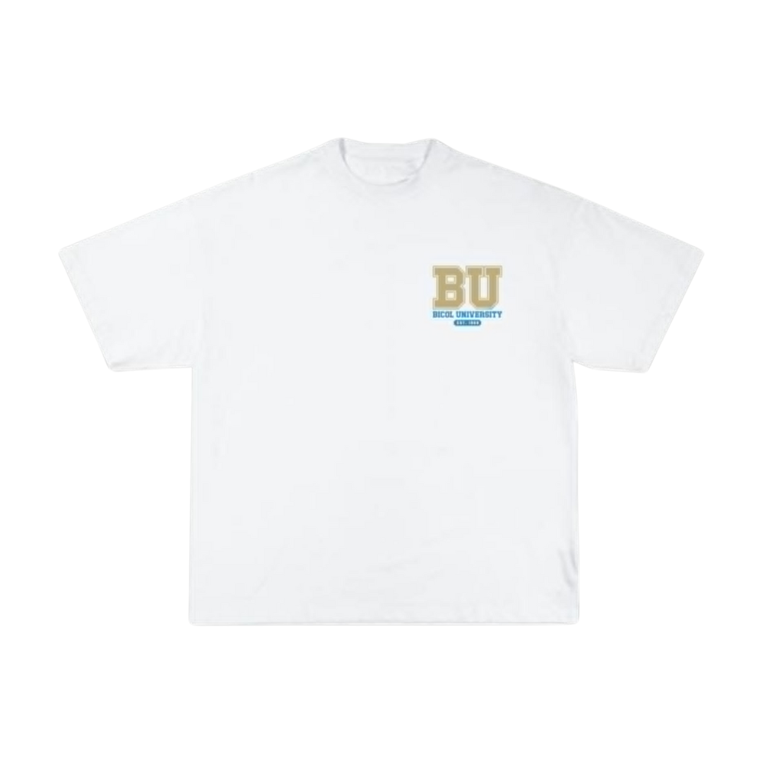 | Shirts | PHP 280.00 | Extra Small, Small, Medium, Large, Extra Large, 2XL | Shirts
Lauaan Street | Black | 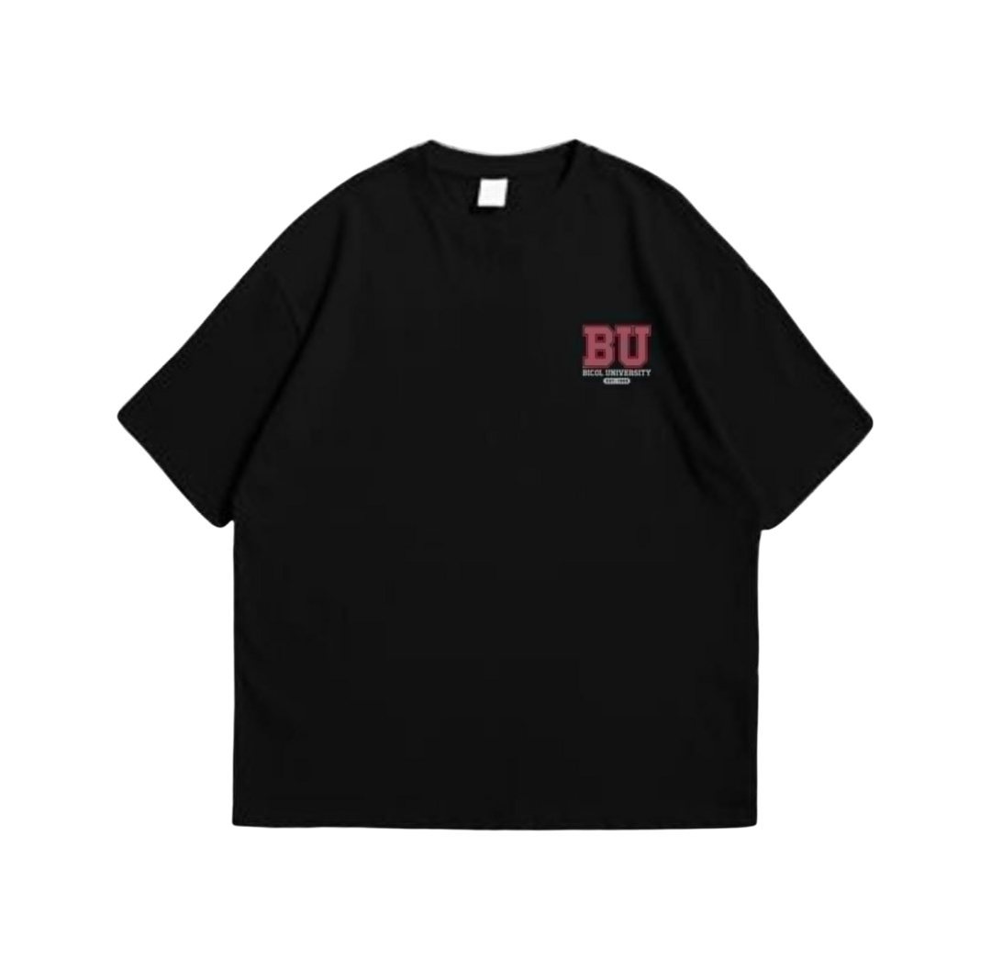 | Shirts | PHP 280.00 | Extra Small, Small, Medium, Large, Extra Large, 2XL | Shirts
Baby Tee | Blue |  | Shirts | PHP 280.00 | Extra Small, Small, Medium, Large, Extra Large, 2XL | Shirts
Baby Tee | Red | 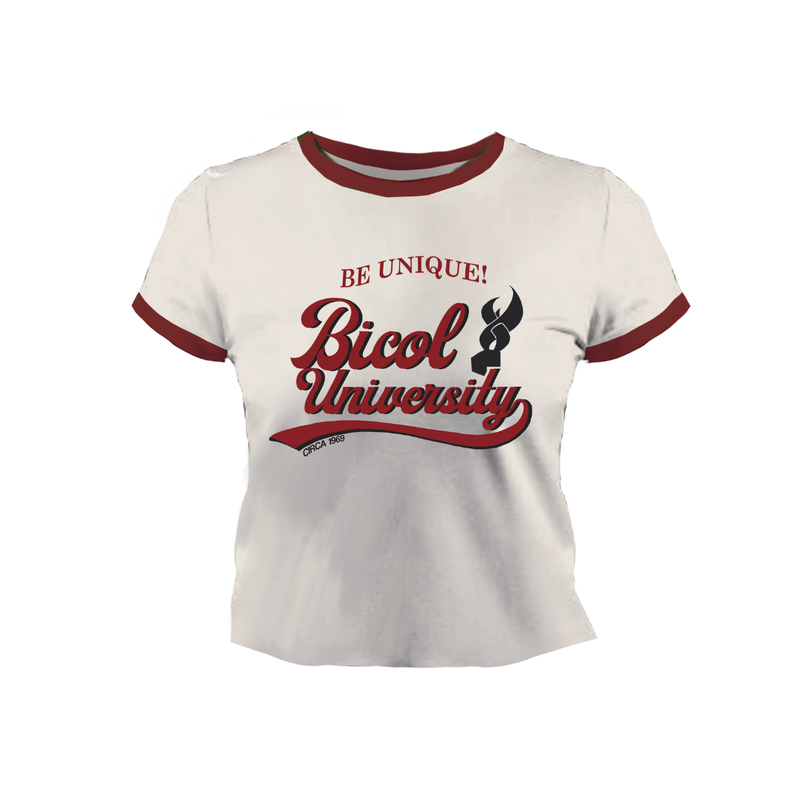 | Shirts | PHP 280.00 | Extra Small, Small, Medium, Large, Extra Large, 2XL | Shirts
Baby Tee | Green |  | Shirts | PHP 280.00 | Extra Small, Small, Medium, Large, Extra Large, 2XL | Shirts
Varsity Jacket
BUNIQUE Varsity Jacket | — | 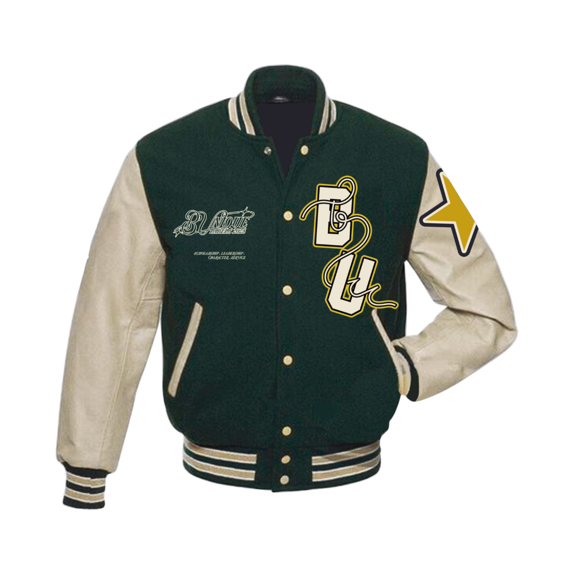 | Varsity Jacket | PHP 2,200.00 | Small, Medium, Large, Extra Large | Jackets
Windbreakers
BUNIQUE Windbreaker | Octans (Blue) |  | Windbreakers | PHP 1,200.00 | Extra Small, Small, Medium, Large, Extra Large, 2XL, 3XL | Windbreakers
BUNIQUE Windbreaker | Fornax (Black) |  | Windbreakers | PHP 1,200.00 | Extra Small, Small, Medium, Large, Extra Large, 2XL, 3XL | Windbreakers
BUNIQUE Windbreaker | Volans (White) | 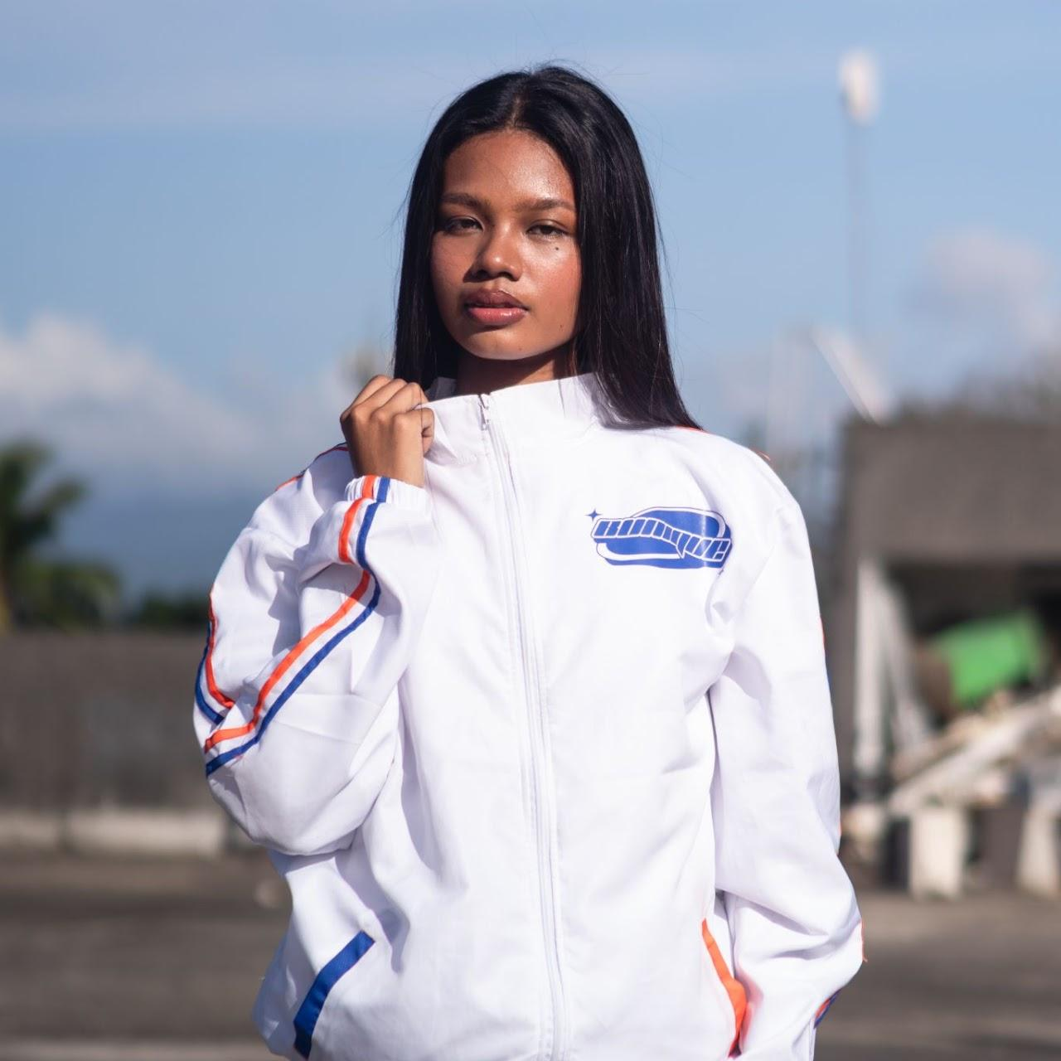 | Windbreakers | PHP 1,200.00 | Small, Medium, Large, Extra Large, 2XL, 3XL | Windbreakers

